**Task-3**

Apply Decision tree and Random forest and get good accurecy (<https://www.kaggle.com/datasets/nishathakkar/100-sales>)

1. **Task** **Description:**

* The goal of this task is to build and evaluate Decision Tree and Random Forest classifiers on the given sales dataset. The primary objective is to achieve good accuracy in predicting the target variable

1. **Task Output Screenshot:**

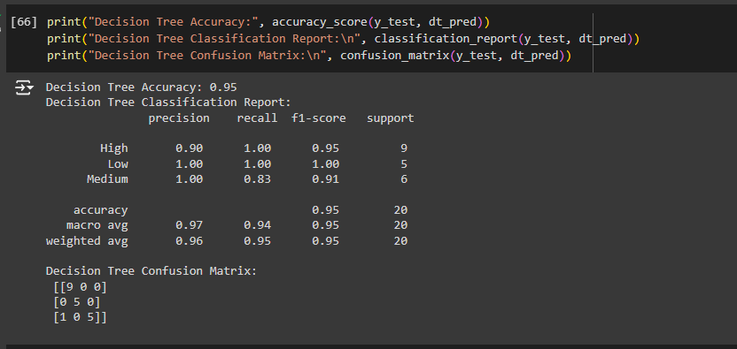

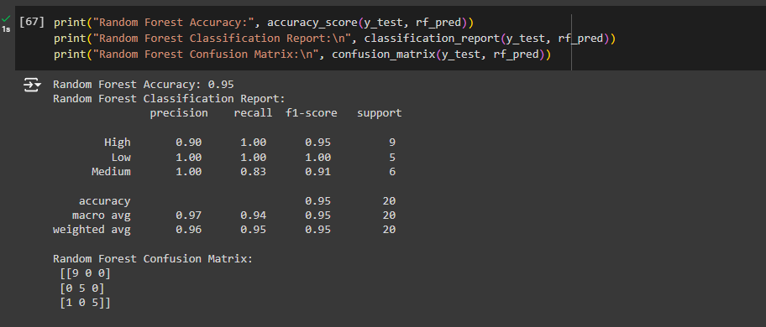

1. **Algorithm Used In Task**

* Preprocessed dataset ready for modeling.
* Trained models for Decision Tree and Random Forest with optimal hyperparameters.
* Evaluation report with accuracy, classification report, and confusion matrix for each model.
* Final summary comparing model performance and detailing which model best meets the objective of high accuracy for sales prediction.